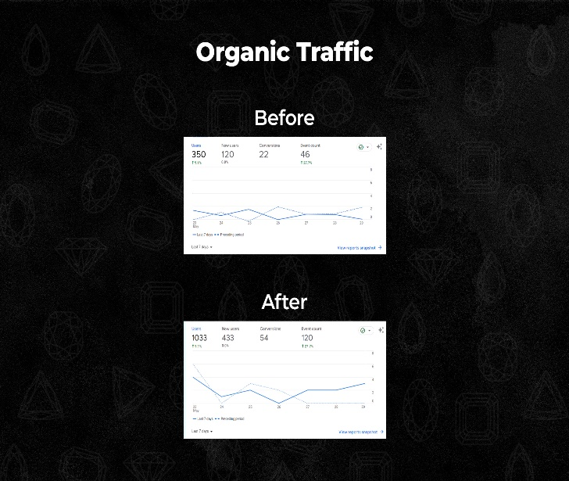

**Before:** Before implementing our SEO strategies, the Al Masaood website had 350 users, 120 new users, 22 conversions, 46 event counts.

**After:** After implementing SEO strategies, we registered 1033 users (up 195%), 433 new users (up 261%), 54 conversions (up 145%), 120 event counts (up 161%). Our SEO efforts led to significant growth and improved organic traffic across key metrics on the Al Masaood website.

**Before:** Al Masaood website had low keyword rankings and impressions. **After:** Significant improvements were seen with higher rankings and increased impressions. Keywords like Oriental Gemco and Wonderslice Menu achieved better rankings, resulting in increased impressions. Other keywords, such as Abdulla Al Masaood & Sons and Nigaam, also showed improved rankings. The SEO efforts successfully enhanced the visibility and performance of Al Masaood website in search engine results.

**Before SEO:** The overall page performance and page load of the website were poor, with ratings of 31 for Performance, 40 for Accessibility, 43 for Best Practices, and 36 for SEO.

**After implementing SEO:** Significant improvements were achieved. The overall page performance and page load increased to 91, with Accessibility reaching 86, Best Practices at 100, and SEO score reaching an impressive 92. These enhancements demonstrate the positive impact of the SEO efforts on the website's performance, accessibility, best practices, and SEO optimization.

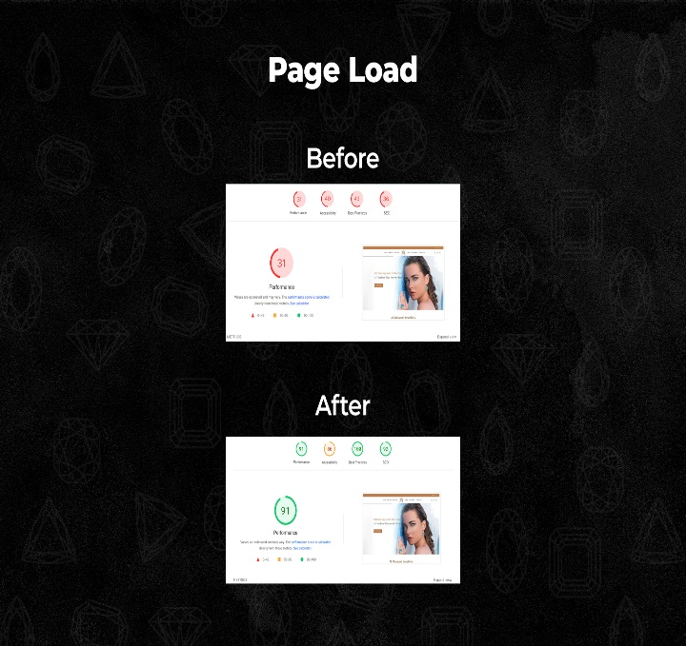

**Before SEO:** The website was not mobile-friendly, and the clickable elements were placed too close together, causing usability issues.

**After implementing SEO:** Significant improvements were made, resulting in a mobile-friendly website with a seamless page structure. The mobile page is now user-friendly and provides a smooth browsing experience, addressing the previous concerns and ensuring optimal usability for mobile users**.**